**Total Seats**

SELECT

DISTINCT COUNT (Parliament_Constituency) AS Total_Seats

FROM constituencywise_results



**Total Seats Won by NDA Allianz**

SELECT

SUM(CASE

WHEN party IN (

'Bharatiya Janata Party - BJP',

'Telugu Desam - TDP',

'Janata Dal (United) - JD(U)',

'Shiv Sena - SHS',

'AJSU Party - AJSUP',

'Apna Dal (Soneylal) - ADAL',

'Asom Gana Parishad - AGP',

'Hindustani Awam Morcha (Secular) - HAMS',

'Janasena Party - JnP',

'Janata Dal (Secular) - JD(S)',

'Lok Janshakti Party(Ram Vilas) - LJPRV',

'Nationalist Congress Party - NCP',

'Rashtriya Lok Dal - RLD',

'Sikkim Krantikari Morcha - SKM'

) THEN [Won]

ELSE 0

END) AS NDA_Total_Seats_Won

FROM

partywise_results

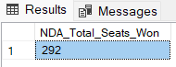

**Seats Won by NDA Allianz Parties**

SELECT

party as Party_Name,

won as Seats_Won

FROM

partywise_results

WHERE

party IN (

'Bharatiya Janata Party - BJP',

'Telugu Desam - TDP',

'Janata Dal (United) - JD(U)',

'Shiv Sena - SHS',

'AJSU Party - AJSUP',

'Apna Dal (Soneylal) - ADAL',

'Asom Gana Parishad - AGP',

'Hindustani Awam Morcha (Secular) - HAMS',

'Janasena Party - JnP',

'Janata Dal (Secular) - JD(S)',

'Lok Janshakti Party(Ram Vilas) - LJPRV',

'Nationalist Congress Party - NCP',

'Rashtriya Lok Dal - RLD',

'Sikkim Krantikari Morcha - SKM'

)

ORDER BY Seats_Won DESC

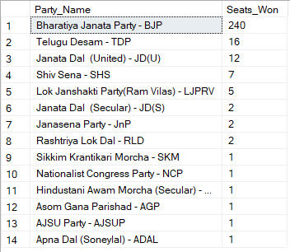

**Total Seats Won by I.N.D.I.A. Allianz**

SELECT

SUM(CASE

WHEN party IN (

'Indian National Congress - INC',

'Aam Aadmi Party - AAAP',

'All India Trinamool Congress - AITC',

'Bharat Adivasi Party - BHRTADVSIP',

'Communist Party of India (Marxist) - CPI(M)',

'Communist Party of India (Marxist-Leninist) (Liberation) - CPI(ML)(L)',

'Communist Party of India - CPI',

'Dravida Munnetra Kazhagam - DMK',

'Indian Union Muslim League - IUML',

'Nat`Jammu & Kashmir National Conference - JKN',

'Jharkhand Mukti Morcha - JMM',

'Jammu & Kashmir National Conference - JKN',

'Kerala Congress - KEC',

'Marumalarchi Dravida Munnetra Kazhagam - MDMK',

'Nationalist Congress Party Sharadchandra Pawar - NCPSP',

'Rashtriya Janata Dal - RJD',

'Rashtriya Loktantrik Party - RLTP',

'Revolutionary Socialist Party - RSP',

'Samajwadi Party - SP',

'Shiv Sena (Uddhav Balasaheb Thackrey) - SHSUBT',

'Viduthalai Chiruthaigal Katchi - VCK'

) THEN [Won]

ELSE 0

END) AS INDIA_Total_Seats_Won

FROM

partywise_results

**Seats Won by I.N.D.I.A. Allianz Parties**

SELECT

party as Party_Name,

won as Seats_Won

FROM

partywise_results

WHERE

party IN (

'Indian National Congress - INC',

'Aam Aadmi Party - AAAP',

'All India Trinamool Congress - AITC',

'Bharat Adivasi Party - BHRTADVSIP',

'Communist Party of India (Marxist) - CPI(M)',

'Communist Party of India (Marxist-Leninist) (Liberation) - CPI(ML)(L)',

'Communist Party of India - CPI',

'Dravida Munnetra Kazhagam - DMK',

'Indian Union Muslim League - IUML',

'Nat`Jammu & Kashmir National Conference - JKN',

'Jharkhand Mukti Morcha - JMM',

'Jammu & Kashmir National Conference - JKN',

'Kerala Congress - KEC',

'Marumalarchi Dravida Munnetra Kazhagam - MDMK',

'Nationalist Congress Party Sharadchandra Pawar - NCPSP',

'Rashtriya Janata Dal - RJD',

'Rashtriya Loktantrik Party - RLTP',

'Revolutionary Socialist Party - RSP',

'Samajwadi Party - SP',

'Shiv Sena (Uddhav Balasaheb Thackrey) - SHSUBT',

'Viduthalai Chiruthaigal Katchi - VCK'

)

ORDER BY Seats_Won DESC

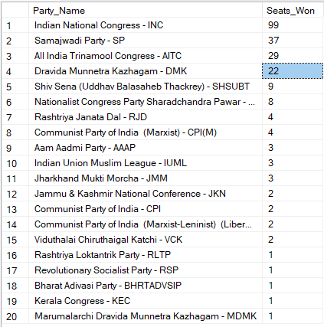

**Add new column field in table partywise_results to get the Party Allianz as NDA, I.N.D.I.A and OTHER**

ALTER TABLE partywise_results

ADD party_alliance VARCHAR(50);

**I.N.D.I.A Allianz**

UPDATE partywise_results

SET party_alliance = 'I.N.D.I.A'

WHERE party IN (

'Indian National Congress - INC',

'Aam Aadmi Party - AAAP',

'All India Trinamool Congress - AITC',

'Bharat Adivasi Party - BHRTADVSIP',

'Communist Party of India (Marxist) - CPI(M)',

'Communist Party of India (Marxist-Leninist) (Liberation) - CPI(ML)(L)',

'Communist Party of India - CPI',

'Dravida Munnetra Kazhagam - DMK',

'Indian Union Muslim League - IUML',

'Jammu & Kashmir National Conference - JKN',

'Jharkhand Mukti Morcha - JMM',

'Kerala Congress - KEC',

'Marumalarchi Dravida Munnetra Kazhagam - MDMK',

'Nationalist Congress Party Sharadchandra Pawar - NCPSP',

'Rashtriya Janata Dal - RJD',

'Rashtriya Loktantrik Party - RLTP',

'Revolutionary Socialist Party - RSP',

'Samajwadi Party - SP',

'Shiv Sena (Uddhav Balasaheb Thackrey) - SHSUBT',

'Viduthalai Chiruthaigal Katchi - VCK'

);

**NDA Allianz**

UPDATE partywise_results

SET party_alliance = 'NDA'

WHERE party IN (

'Bharatiya Janata Party - BJP',

'Telugu Desam - TDP',

'Janata Dal (United) - JD(U)',

'Shiv Sena - SHS',

'AJSU Party - AJSUP',

'Apna Dal (Soneylal) - ADAL',

'Asom Gana Parishad - AGP',

'Hindustani Awam Morcha (Secular) - HAMS',

'Janasena Party - JnP',

'Janata Dal (Secular) - JD(S)',

'Lok Janshakti Party(Ram Vilas) - LJPRV',

'Nationalist Congress Party - NCP',

'Rashtriya Lok Dal - RLD',

'Sikkim Krantikari Morcha - SKM'

);

**OTHER**

UPDATE partywise_results

SET party_alliance = 'OTHER'

WHERE party_alliance IS NULL;

**How many seats did the a Party win in each state, and which states had the highest number of seats won by Party under the various alliance?**

SELECT cr.State, p.Party, p.party_alliance, Count(cr.Constituency_ID) AS Seats_Won

FROM constituencywise_results cr

LEFT JOIN partywise_results p ON cr.Party_ID = p.Party_ID

LEFT JOIN statewise_results sr ON cr.Parliament_Constituency = sr.Parliament_Constituency

WHERE p.Party = 'Bharatiya Janata Party - BJP'

GROUP BY cr.State, p.Party, p.party_alliance

ORDER BY Count(cr.Constituency_ID) DESC

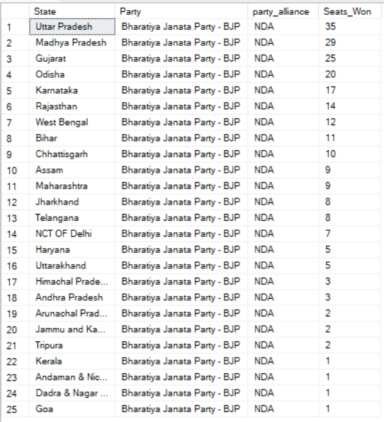

**Winning candidate's name, their party name, total votes, and the margin of victory for a specific state and constituency?**

SELECT cr.Winning_Candidate, p.Party, cr.Total_Votes, cr.Margin, cr.Constituency_Name, s.State

FROM constituencywise_results cr

JOIN partywise_results p ON cr.Party_ID = p.Party_ID

JOIN statewise_results sr ON cr.Parliament_Constituency = sr.Parliament_Constituency

JOIN states s ON sr.State_ID = s.State_ID

WHERE s.State = 'Uttar Pradesh' AND cr.Constituency_Name = 'AMETHI';

